



Project Title: GRADE CALCULATOR
(Relative Grading System using Standard Deviation)

UNIVERSITY NAME: VIT Bhopal University
NAME: RAJAT TIWARI
REGISTRATION NUMBER: 25BAI10250
SLOT: C14+E11+E14

- Approach & Methodology

> Overview

The Grade Calculator adopts a Relative Grading System (often referred to as "grading on the curve"). Unlike absolute grading, where grades are fixed (e.g., >90 is an A), this system determines a student's grade based on their performance relative to the class average. To achieve this, the project utilizes two key statistical metrics: Mean ($\mu$) and Standard Deviation ($\sigma$).

> Mathematical Logic

The core algorithm relies on the Normal Distribution model to calculate
grade thresholds.

- Calculation of Mean (μ):
First, the system calculates the class average.
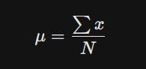

- Calculation of Standard Deviation (σ):
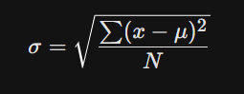
The system computes the standard deviation to measure the dispersion of scores (how spread out the marks are from the average).
- Relative Grading System using Standard Deviation: -

Step 1: Start Initialize the program.

Step 2: Input Data
- Prompt the user to enter the total number of students (N).
- Initialize an empty list class_scores to store marks.
- Start a loop from i = 1 to N:
  - Read the score for student i.
  - Append the score to the class_scores list.

Step 3: Calculate Statistics
1.Calculate the Class Mean (μ) of the scores in class_scores.
2. Calculate the Standard Deviation (σ) of the scores.
3. Display the calculated Mean and Standard Deviation to the user.

Step 4: Process Individual Scores
Iterate through every score in the class_scores list:

- Calculate Z-Score:
  - If Standard Deviation (σ) is 0, set Z-score to 0.
  - Otherwise, compute Z-score using the formula:
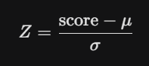
2.Assign Grade: Call the grade mapping logic using the calculated Z-score.

Step 5: Grade Assignment Logic (Sub-routine)
Determine the letter grade based on the Z-score intervals:
- If Z >= 2.0: Assign 'S' (Outstanding)
- Else If Z >= 1.0: Assign 'A'
- Else If Z >= 0.5: Assign 'B'
- Else If Z >= -0.5: Assign 'C' (Average)
- Else If Z >= -1.3: Assign 'D'
- Else: Assign 'F' (Fail)

Step 6: Output Results
- Store the assigned grade for the current score.
- Print the individual score and its corresponding grade.

Step 7: End Terminate the program.

- Program Code: -
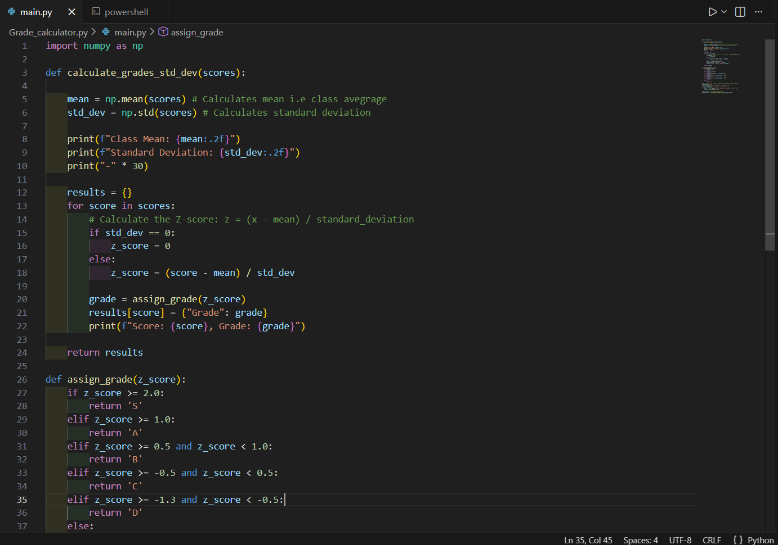
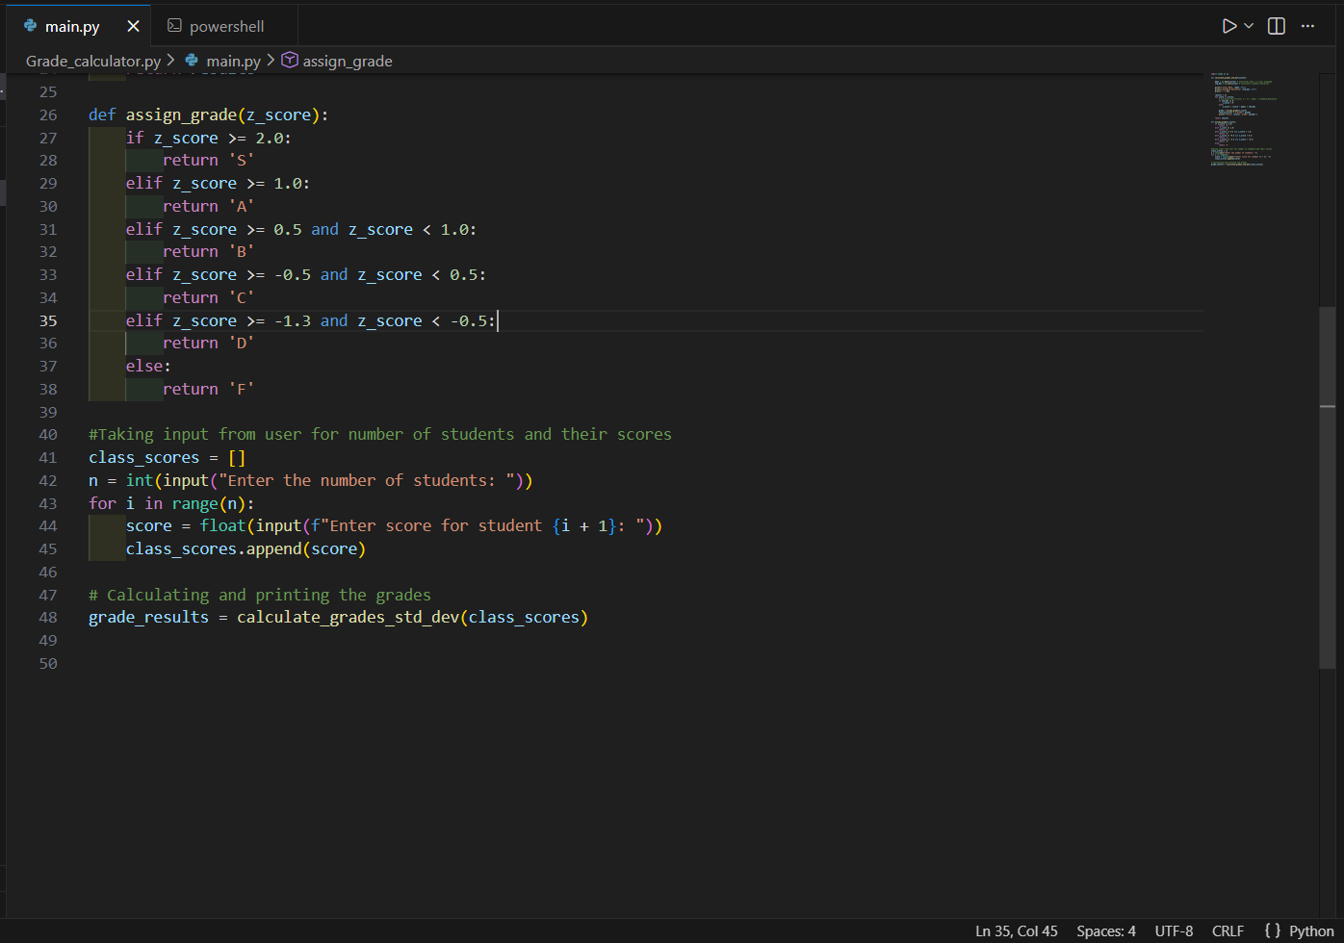
- Implementation: -

Programming Language: Python
Key Library: NumPy (Numerical Python)

Used for its simplicity and ease of handling input/output operations.

User Interface: Console-based, menu-driven system

The user sees clear options like: -

1. Takes number of students (n) as input from user
2. Input marks ok each student
3. Calculates the mean, standard deviation and grade
4. Gives the Output
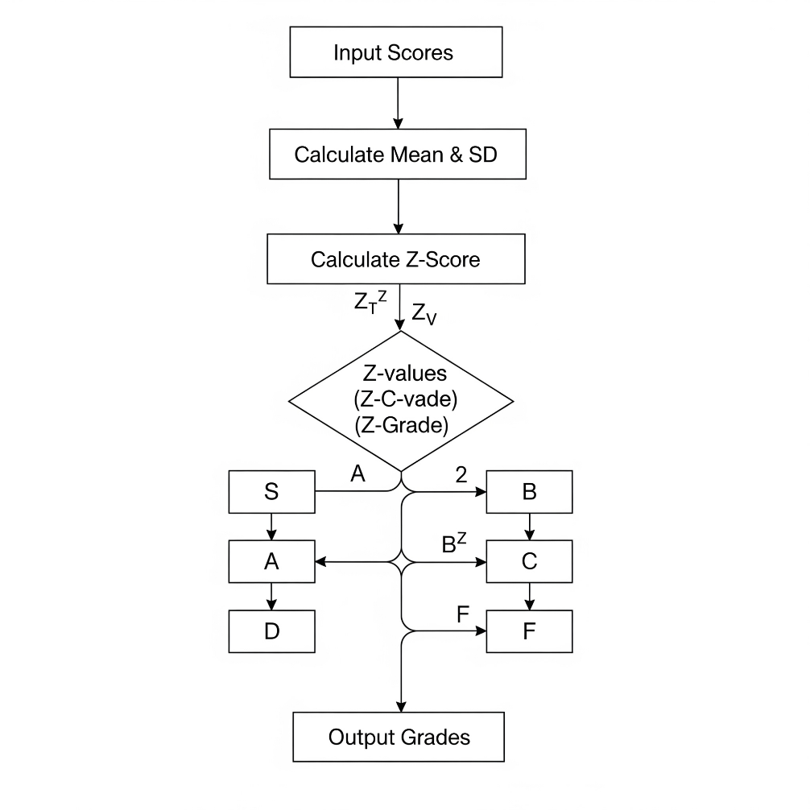
- Screenshots / Visuals: -

Include screenshots showing: -

- Taking input of number of students

- Input Marks

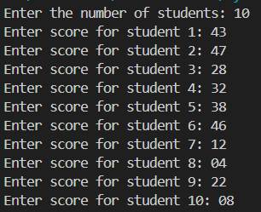

- Calculated Output (Mean and Standard deviation)

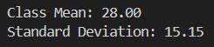

- Calculated Grade

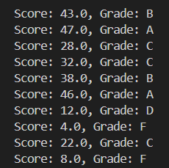

>>Full Output Screenshot

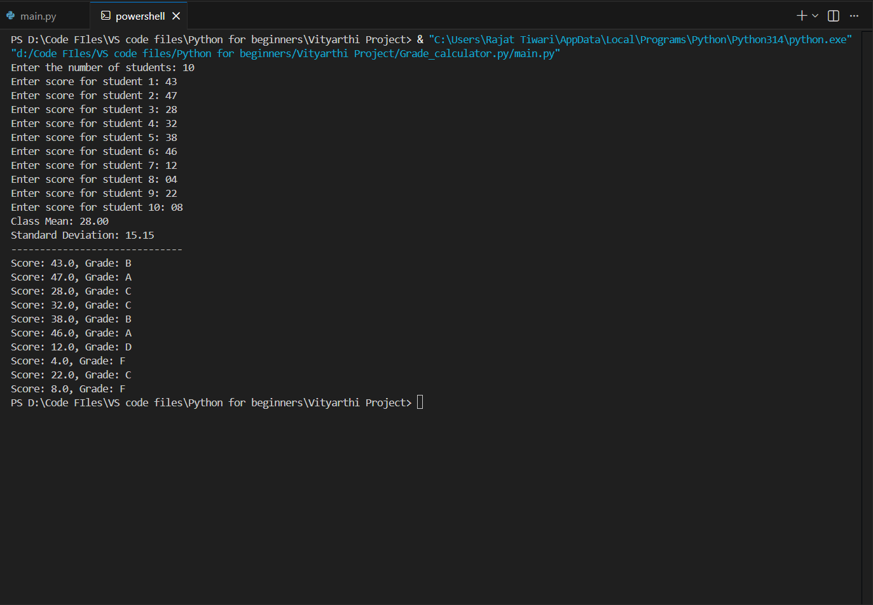
- Testing and Validation: -

5.1. Overview
To ensure system reliability, a multi-layered testing approach was employed, verifying statistical accuracy (Mean, SD) and logical correctness (Grade Assignment). All program outputs were cross-verified against manual calculations to guarantee mathematical precision.

5.2. Test Scenarios & Results
The system was tested against four primary scenarios to validate robustness:
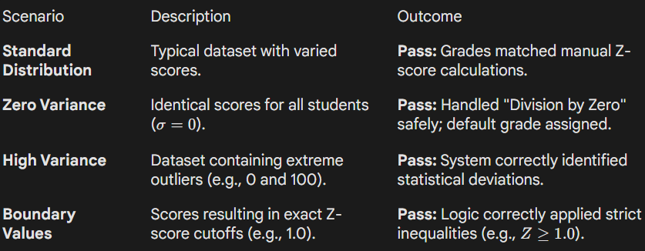

5.3. Conclusion
The application successfully passed all functional and edge-case tests. The implementation of NumPy ensured high floating-point precision, and explicit error handling prevented runtime failures during zero-variance scenarios.

- Challenges Faced & Solutions: -

- Division by Zero (Zero Variance):
When all students scored identical marks, the Standard Deviation (σ) became zero, causing a runtime error in the Z-score formula.
- Solution: Implemented a conditional check to detect σ = 0 and automatically assign a default neutral grade (C) instead of crashing.

- Defining Grade Thresholds:
Determining the exact Z-score cutoffs for a fair relative grading curve was subjective.
- Solution: Adopted standard academic statistical models (e.g., Grade 'S' for Z >= 2.0) to ensure the highest grades are exclusive to the top percentile.

- Precision & Accuracy:
Standard Python math operations could lead to minor floating-point rounding errors.
- Solution: Utilized the NumPy library to handle statistical calculations, ensuring high-precision results for Mean and Standard Deviation.

- Learnings & Key Takeaways: -

This project provided valuable insights into both software development and statistical mathematics. The key takeaways include:
- Practical Application of Statistics: Moved beyond theoretical knowledge of the Normal Distribution (Bell Curve) to implement it in a real-world scenario. Understanding how Z-scores normalize data was crucial for creating a fair grading system that works regardless of the test's difficulty level.

- Efficiency of Python Libraries: Gained hands-on proficiency with NumPy. We learned that for statistical operations, utilizing optimized libraries is significantly faster and more readable than writing manual loops for calculation, especially with larger datasets.

- Importance of Edge Case Handling: Discovered that a "working" algorithm isn't enough; it must be robust. Handling the "Zero Variance" scenario (where all students score the same) highlighted the importance of anticipating and coding for mathematical anomalies to prevent runtime crashes.

- Algorithmic Logic Building: Enhanced skills in converting continuous data (floating-point Z-scores) into discrete categories (Letter Grades) using conditional logic and decision trees.

- Real-World Relevance: Developed a deeper appreciation for how academic institutions calculate relative grades. This tool demonstrates that a student's grade is not just about their raw score, but their performance relative to the peer group.

- Future Enhancements: -

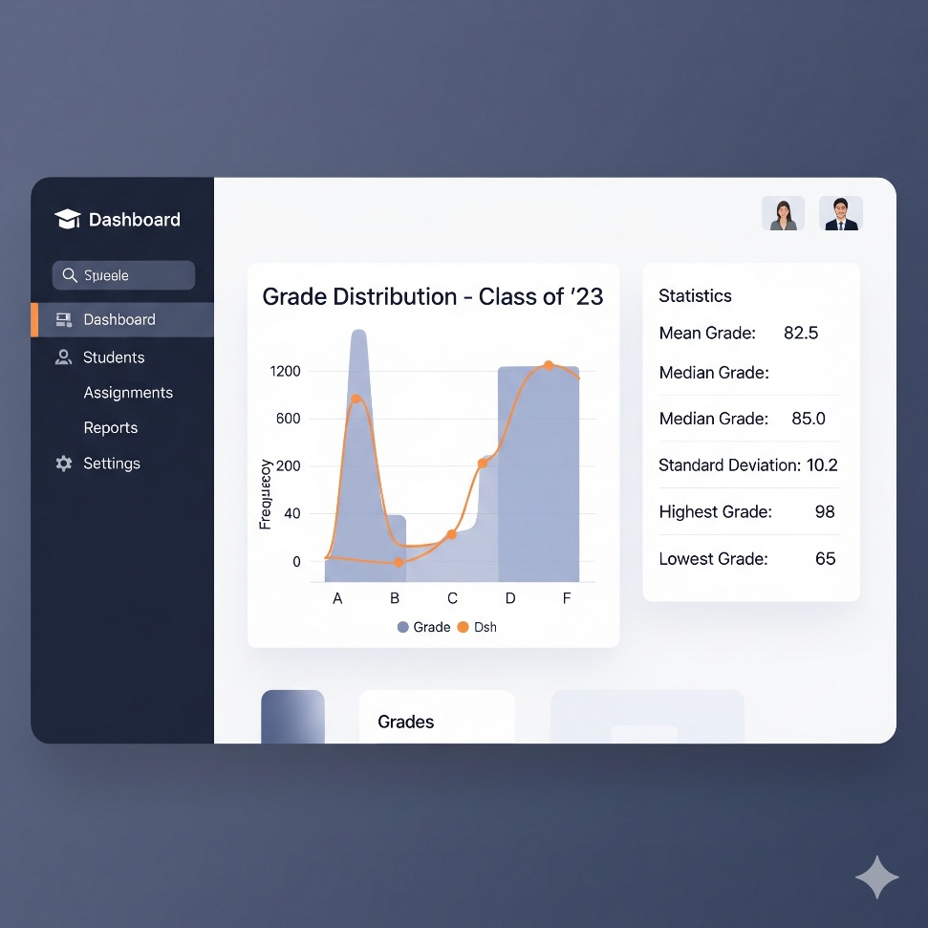

- Graphical User Interface (GUI): Develop a user-friendly desktop or web interface (using Tkinter or Flask) to replace the command-line input.

- Data Visualization: Integrate Matplotlib to generate visual histograms and Bell Curve graphs of class performance (as shown in the concept above).

- File Integration: Add support for importing scores directly from CSV or Excel files to handle large datasets efficiently.

- Customizable Thresholds: Allow instructors to manually configure Z-score cutoffs to adjust for varying course difficulty levels.

- Report Generation: Implement a feature to export final grades and statistical summaries into downloadable PDF reports.

- Practical Uses: -

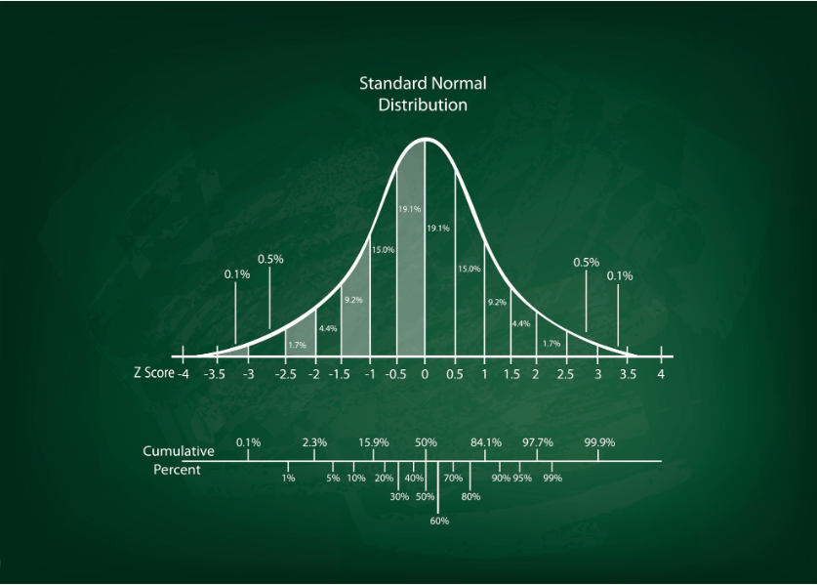

- Fair Assessment: Automatically adjusts grades based on class performance, ensuring students aren't penalized for exceptionally difficult exams.

- Bias Elimination: Removes subjective human error by relying strictly on statistical metrics (Mean & Standard Deviation) for grading.

- Outlier Detection: Instantly flags high achievers (Z > 2.0) for rewards and at-risk students (Z < -1.3) for remedial support.

- Scalability: efficiently handles grading for large-scale standardized tests or entrance exams where relative ranking matters more than absolute scores.

